## repeat the assignment you are implementing;

Finish the ResolveCollisionWith method to handle collisions with balls of the same mass in a generic manner.

## explain your approach;

First detect if there is a collision, then simply executed the vector math required for this.

## describe your code;

If the difference in length is smaller then the two radii added tighter there is an overlap, then get the collision normal. Fix interpenetration, used collusion normal and difference in velocity to get the dot product. Use the dot product and the collision normal to get the change in velocity vector, and then apply it to the velocity’s of both objects.

## show (relevant) code snippets;

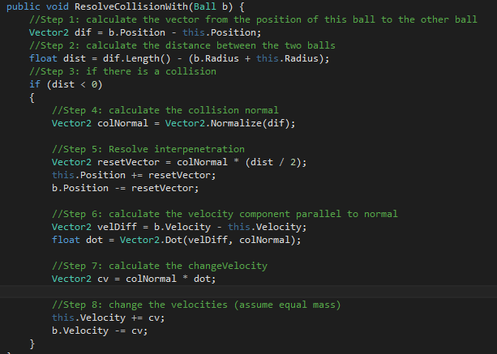  
The entire method.

## include a screenshot of your program

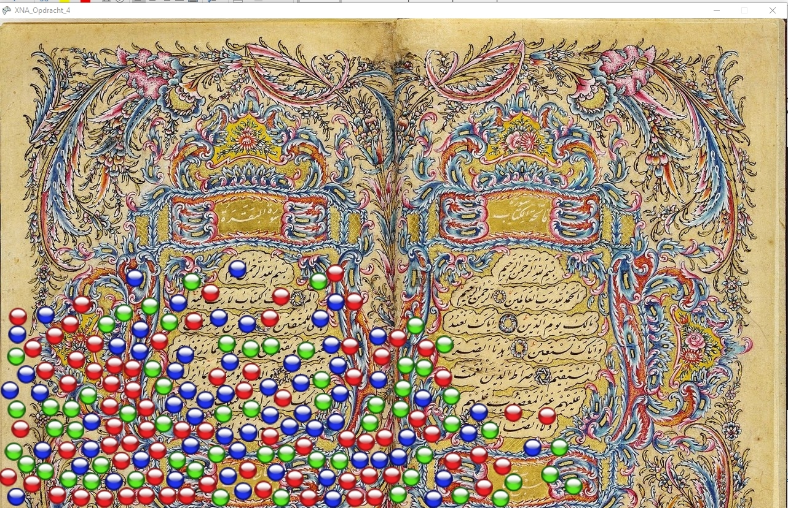

Again I have made video’s for the class as well These are found here: <https://www.youtube.com/watch?v=9uMnr0EeFzI&t=987s&list=PLARkMALdMekM6EMkY0gcQSKvADVAx9zK5&index=6>